Genetic Analysis of C. elegans Dumpy Mutants
Kayla Arce

Abstract
Caenorhabditis elegans is an important model organism which can be used to understand human genetics. Dumpy worms have a mutation which affects the cuticle, or the outer layer, causing them to appear shorter and wider. There are several different gene mutations which can cause this phenotype. In this experiment an unknown strain of dumpy worms called “H” was analyzed using backcrossing, linkage crossing, mapping analysis, gene sequencing and by treating with RNAi. These analyses showed that the unknown strain had the dpy-18 gene mutation on chromosome 3. It also showed that it has a dominant mode of inheritance. qRT-PCR analysis showed that dpy-18 causes a suppression of gene expression. GFP visualization showed that it has a mild suppression of gene expression in the pharyngeal muscle and gut tissues.

Introduction
Caenorhabditis elegans has long been used as a model organism. It is small, has a short lifespan, and is easy to work with. Many genes found in c. elegans are also found in humans. There also exist a large number of mutations in this species which have been well researched and documented. By studying this model organism, we can gain greater understanding of the mechanisms involved in gene expression in humans. This can be applied towards the development of treatments and therapies for genetic disorders.
Some c. elegans can have a mutation called dumpy. These worms are shorter and stouter in appearance than the wildtype. The most likely cause of this phenotype is a mutation in the collagenous exoskeleton of the worm called the cuticle [1]. Since a large number of genes code for different collagen proteins dispersed throughout the genome, many mutations can cause a dumpy phenotype [1,2]. The cuticle is shed at each of the four stages of life and reformed and secreted by hypodermal cells [2]. Development of the cuticle is important as it affects the structure and shape of the worm. It also has many similarities to the proteins found in human skin, such as collagen.
In this experiment I a dumpy mutant strain of C. elegans was worked with. The purpose was to determine the mode of inheritance, identify the gene involved, and analyze its effect on gene expression overall and in specific tissues.

Methods

Making a Worm Pick
The tip of a glass pipette was broken off so that a small piece of platinum about 2 cm long could be inserted, with 1 cm sticking out. Then they were rotated over a bunsen burner flame until the glass melted and secured the wire in place. A razor blade was used to flatten the end of the wire so that it can more easily scoop up worms.

Maintaining Worm Cultures
The C. elegans were grown on petri plates containing mutant E. coli strain OP50. In order to maintain worm lines for extended periods the chunking technique was used. Using a sterilized spatula, a small section of agar was cut out from plates and moved worm side down to a new plate and then removed.

Backcrossing Mutants
Three cross plates were prepared by transferring 3 L4 DR466 males and 4 L4 mutant hermaphrodites to each plate. The cross plates were then incubated at 20°C for 3 days. Then 2 wildtype L4 heterozygous hermaphrodites from the F1 offspring of each successful plate (based on containing male offspring) were transferred to new plates and incubated for another 3 days. Success of F2 progeny was based on number of each phenotype and all offspring being hermaphrodites.

Linkage Analysis
Five different crosses were generated using reference strains CB51, CB120, CB189, CB152, and CB270 containing reference mutant markers to test each chromosome. Each plated cross contained 3 heterozygous males from the F1 generation of the backcrossed strains and 3 L4 hermaphrodites from one of the unc mutant reference strains. Plates were incubated for 3 days at 20°C. Then 2 wildtype L4 hermaphrodites from the F1 progeny of each plate were transferred to 2 new plates each and incubated for 3 days. F2 progeny were analyzed to determine the presence or absence of double mutants.

Mapping Analysis
Using the F2 progeny from the linkage analysis plates that contained no double mutants, 6 unc mutants were transferred to individual plates and incubated for 3 days. Three double mutant progeny were then transferred to individual plates and incubated for 3 more days. Then 3 L4 hermaphrodite double mutant offspring were transferred to 2 new plates along with 3 wild-type males. After 3 days of incubation the progeny were analyzed by counting the number of double mutants, single mutants and wildtypes. These numbers were then used to calculate the recombination frequency and map distance of the mutant gene to the reference gene. Once the number of base pairs between the mutant and reference gene was determined, the mutant gene was identified using the online tool Gbrowse on Wormbase.org.

GFP Marker Crosses
For tissue analysis, 2 plates were generated by placing 4 L4 mutant hermaphrodites and 6 GFP positive males from the TY4236 (pharyngeal muscle and gut) strain to each plate. Successful F1 progeny were all wildtype in appearance. Then 3 new plates were created by transferring 1 F1 hermaphrodite to each plate. Mutants from the F2 generation were placed on a glass slide with agarose and sodium azide to paralyze them. Slides were then analyzed via GFP microscopy.

RNAi Feeding Strain

Isolating Genomic DNA
10 µl of worm lysis buffer and 7 live worms were placed into two 0.2ml PCR tubes, one tube with “H” mutant worms, the other with wildtype worms. The tubes were centrifuged for 5 seconds, then frozen at -80°C for 10 minutes, and then lysed at 65°C for 90 minutes in a hot water bath. After lysis, the Proteinase K was inactivated by heating the tubes to 95°C for 15 minutes.

Amplifying DNA by PCR
To 4 PCR tubes containing a PCR bead 20.5 µl of dH₂O was added. Then to 2 tubes 2.5 µl of “H” mutant DNA was added. To the other 2 tubes 2.5 µl of wildtype DNA was added. One mutant and one wildtype tube were placed in the PCR thermal cycler using the program with an annealing temperature of 55°C. The other tubes were placed in the thermocycler using the program with an annealing temperature of 60°C. Tubes were stored at -20°C.

Restriction Enzyme Digest of PCR product and L4440 Vector
Next 1 µl of BglII and 1 µl of Xhol were added to the 2 wildtype PCR tubes. In another tube 4 µl of L4440 vector DNA, 1 µl of BglII, 1 µl of Xhol, 2 µl of Buffer Cutsmart, 2 µl of BSA and 10 µl of dH₂O were added. All three tubes were then incubated at 37°C for 1 hour, then stored at -20°C.

Analysis of Restriction Enzyme Fragments by Gel Electrophoresis
The five samples (Mutant PCR, digested Wildtype PCR, and digest vector) were then analyzed via gel electrophoresis on a 1% agarose gel at 120 volts. Once the DNA fragments migrated, they were visualized on a UV transilluminator and then cut out of the gel, weighed and placed into micro test tubes. DNA fragments were then isolated following QIAquick Gel Extraction Kit Protocol to extract and purify the DNA samples from the agarose.

Generating Recombinant DNA by Ligation
Using a NanoDrop the concentrations of the vector, mutant and wildtype DNA were determined. The mutant DNA was stored at -20C. A ligation reaction was set up by transferring 1.5 µl of wildtype DNA, 9 µl of vector DNA, 2 µl of ligase buffer, 1 µl of T4 DNA Ligase, and 6.5 µl of dH₂O to a tube. The ligation reaction tube was then incubated at room temperature for 10 minutes.

Amplifying Recombinant DNA by Bacterial Transformation
To a tube containing 50 µl of HT115 bacteria, 4 µl ligation reaction was added. Both tubes were incubated on ice for 15 minutes then heat shocked in a 42°C water bath for 30 seconds and then returned to ice for 2 minutes. Both tubes received 250 µl of recovery broth followed by incubation at 37°C for 30 minutes. After the recovery period, 100 µl of the solution from the tubes were transferred to individual LB+amp agar plates and incubated at 37°C.

Setting Up Bacterial Cultures to Seed NGM Agar Plates
From the recombinant bacteria plate, a single colony was isolated and transferred to a tube containing 2 ml of LB. A colony from a pL4440-GFP plate and an HTT15 plate were similarly isolated and transferred to individual LB tubes. The tubes were incubated at 37°C overnight with shaking.
The broth from these tubes were transferred to 2 agarose plates each. To each plate 4 L4 hermaphrodite wildtype worms were added. The HTT15 plates were used as a negative RNAi control. The recombinant plates were the treatment plates. The pL4440-GFP plates were used as a positive GFP control. The amount of RNAi was analyzed by quantification of fluorescence and phenotype observation.

RNA Isolation and RT-qPCR
Using 200 µl of S buffer, the HTT15 and treatment plates were washed, and the worm were loosened and collected and transferred to tubes. The mutant DNA tube was removed from storage and thawed. The tubes were centrifuged for 4 minutes, and the buffer was discarded. 1 ml of S buffer was added to the tubes, and they were centrifuged again. After discarding the buffer, the protocol from the RNeasy mini kit by Qiagen was followed. The RNA concentrations of the samples were determined using the Nanodrop RNA-40 protocol.
Six RT-qPCR reactions were set up. Each tube contained 10.5 µl of RT-qPCR SYBR Master Mix and 6 µl of water. To tubes 1, 2, and 3, 0.5 µl each of forward and reverse primer were added. To tubes 4, 5, and 6, 0.5 µl each of Tbg-1 forward and reverse were added. Tubes 1 and 4 received 2.5 µl of negative control RNA. Tubes 2 and 5 received 2.5 µl of treatment RNA. Tubes 3 and 6 received 2.5 µl of mutant RNA. The six tubes were placed in a qPCR machine to quantify RNA levels in each reaction tube.

Results

Mutant Hypothesis
In order to determine the mutant phenotype, the worms were observed and compared to the wildtype. The “H” strain of mutants are shorter and proportionately wider compared to the wildtype strain DR466, which are longer and slimmer as seen in Figure 1. These are characteristics of a mild dumpy phenotype.
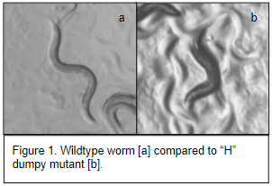

Backcrossing Mutants
In order to determine mode of inheritance, backcrosses were prepared, and offspring were observed. The majority F1 backcrossed worms were heterozygous and displayed a wild phenotype. There were males and hermaphrodites. When heterozygous wildtype L4 hermaphrodites were isolated and transferred to new plates all F2 self-progeny were hermaphrodites and appeared wildtype [Figure 2]. From these results it was concluded that the dumpy mutation is dominant.
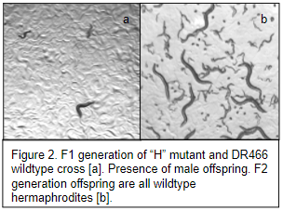

Linkage Analysis
A linkage analysis was performed to determine which of the five chromosomes the mutation is located on. The dumpy mutants were crossed with unc coiling mutants. Each unc reference strain had a mutation on one of the five chromosomes. If the dumpy gene and the reference gene are located on different chromosomes, their offspring will display an independent assortment mode of inheritance and occasional crossing over between the two genes. This can result in double mutant offspring which display both a coiling and dumpy phenotype [Figure 3]. If the genes are both on the same chromosome, crossing over is much less likely to occur. Therefore, by scoring the offspring of the crosses, the chromosome the gene is located on can be identified. Table 1 shows the number of wildtype, unc, dpy, and double mutant offspring for each cross. The only strain that didn’t have double mutant offspring was CB189 which has the unc-32 mutation on chromosome 3. Therefore, it can be concluded that the dumpy gene of interest is located on chromosome 3.
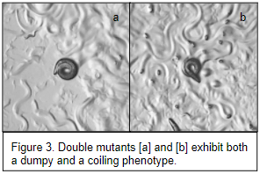
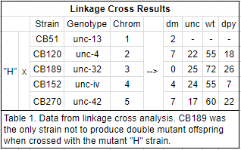

Mapping Analysis
After identifying the chromosome, a mapping cross analysis was performed using CB189 as the reference strain, to determine the distance in base pairs between the unc-32 gene and the mutant gene of interest. Cross progeny were scored and used to calculate the recombination frequency and map units of distance apart. This distance between the mutant and reference gene was then calculated to be 2,190,000 base pairs [Table 2]. Using Gbrowse to search in that area of the genome revealed the dpy-18 gene. According to wormbase, a dpy-18 mutation causes a mild dumpy phenotype, which is what my worms show [3]. This is is more evidence in support of dpy-18 being the gene of interest.
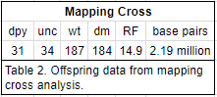

GFP Marker Crosses
GFP marker crossed were used to visualize different tissues and see if they are affected by the dumpy mutation. TY4236 GFP positive mutants express GFP in the pharyngeal muscle and gut. When crossed with the “H” mutants they had slightly reduced GFP expression in their pharyngeal muscle and gut than the control. It can be concluded that the dumpy gene is expressed in the pharyngeal muscle and gut. However, these tissues are not very affected by this mutation.

RNAi Feeding Strain
Based on the gene identified from mapping cross analysis, an RNAi feeding vector was produced to target and inactivate that gene in wildtype worms. Using PCR and restriction enzyme digestion, the gene sequence of interest was isolated and replicated, then introduced as a vector to E.coli. Figure 4 shows dpy-18 DNA being separated by gel electrophoresis after being isolated and amplified via restriction enzyme digest and PCR.
When wildtype worms fed on the RNAi expressed by the recombinant bacteria, dpy-18 gene function was down-regulated. They displayed a dumpy phenotype after one generation. The worms treated with the negative control bacteria displayed a wildtype phenotype. The positive control GFP plate was also all wildtype in appearance [Figure 5]. When the fluorescence of the GFP worms was quantified and compared to a control, there was shown to be significant knockdown of GFP expression. The fact that knockdown of the dpy-18 gene results in a mild dumpy phenotype gives more evidence that dpy-18 is the gene responsible for the dumpy phenotype of the “H” mutants.
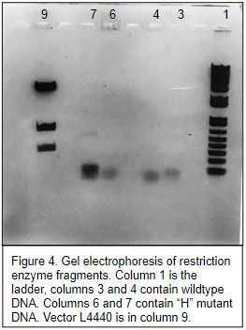
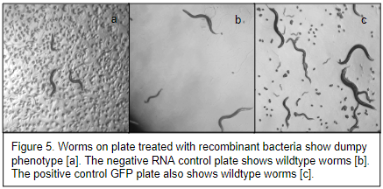

RNA Isolation and RT-qPCR
RT-qPCR analysis was performed to quantify the amount of mRNA in the treatment, mutant, and control strains. Reduced quantities of mRNA indicated reduced gene expression. The RNAi treated worms had a 54.8% reduced mRNA expression, and the “H” mutants had a 36.7% reduced mRNA expression compared to the wildtype worms [Figure 6]. These lower quantities of mRNA indicate that in both the RNAi treated worms and the “H” mutants the dpy-18 gene is down-regulated. This shows that mutation in “H” worms causes under-expression of the dpy-18 gene.
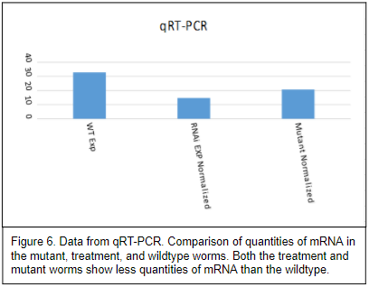

Discussion
The C. elegans mutant “H” strain was observed to have a mild dumpy phenotype. The mutation also is shown to be dominant through backcross analysis. Linkage cross testing identified that the mutation is on chromosome 3. Mapping cross analysis revealed that the gene of interest is located 2.19 million base pairs away from the reference strain mutation. The gene in this area of the genome which causes a mild dumpy phenotype similar to the “H” strain was dpy-18. Wildtype worms treated with RNAi made to knock-down this gene showed a mild dumpy phenotype. qRT-PCR analysis also showed that “H” mutants have reduced expression of this gene.
The dpy-18 gene encodes an alpha-subunit of prolyl-4-hydroxylase (PH4) which is responsible for post-translational modification of procollagen [4]. It works with phy-2, which encodes another subunit of PH4, and PDI-2 to create a varied polymers to form the cuticle [5]. If one protein is absent the other proteins are able compensate, changing the makeup of the cuticle. Dpy-18 is also involved with ten-1 to attach the epidermis to body wall muscles [6]. Based on the results of the experiment, it can be concluded that my “H” mutants had a dpy-18 gene mutation which caused reduced expression of PH4 leading to reduced post-translational modification of procollagen. Without this mechanism, the makeup of the cuticle is altered. There is also less expression of ten-1 which attaches the epidermis to the body wall muscles. The malformed cuticle and slightly detached epidermis cause a dumpy appearance.
The GFP marker cross didn’t show much difference from the control. This is explained by the fact that dpy-18 is predominantly expressed in the hypodermis, head, and posterior neurons [3]. The reference strain TY4236 expresses GFP in the pharyngeal muscle and gut. It would have been better to use a different strain which expresses GFP in the hypodermis such as strain AA278 or in the body wall muscles such as strain KH1125.

Acknowledgements
Special thanks go to Nicole Evans, Diana Young, and the Department of Biological Sciences at Purdue University Northwest for providing instruction, guidance, materials, and equipment necessary to complete this research. I would like to thank Alfa Dhakal, Brett Gawel, and Mustafa Mohamed for their support and help. Additional thanks go to the lab fairies for watching over the lab procedures and making sure all science everywhere gets done.

References
1. Levy AD, Yang J, Kramer JM. Molecular and genetic analyses of the Caenorhabditis elegans dpy-2 and dpy-10 collagen genes: a variety of molecular alterations affect organismal morphology. Molecular Biology of the Cell. 1993;4(8):803-817.
2. Ouazana R, Garrone R, Godet J, Characterization of morphological and biochemical defects in the cuticle of a dumpy mutant of, Comparative Biochemistry and Physiology Part B. Comparative Biochemistry. 1985;90(3):481-484.
3. WormBase.National Human Genome Research Institute; 2011 [accessed 2017 Dec 16]. http://www.wormbase.org/db/get?name=WBGene00001077;class=Gene
4. Hill-Harfe KL, Harfe BD, Dobbins CA, L'Hernault SW. dpy-18 encodes an alpha-subunit of prolyl-4-hydroxylase in caenorhabditis elegans. Genetics. 2000:155:1139-1148.
5. Myllyharju J, Kukkola L, Winter AD, Page AP. The exoskeleton collagens in Caenorhabditis elegans are modified by prolyl 4-hydroxylases with unique combinations of subunits. J Biol Chem. 2002;277(23):187-196
6. Topf U, Chiquet-Ehrismann RE. Genetic interaction between Caenorhabditis elegans teneurin ten-1 and prolyl 4-hydroxylase phy-1 and their function in collagen IV-mediated basement membrane integrity during late elongation of the embryo. Mol Biol Cell. 2011;22:3331-3343

