Kayla Arce
4/29/16
Biostatistics

Motor Vehicle Deaths: 2000-2002 vs 2012-2014

Introduction

Motor vehicle related accidents continue are a major cause of death all across the United States. This data compiles the death rates of motor vehicle accidents from 10 randomly selected states. The cause of deaths includes accidental, suicide, homicide, and undetermined. This data compares the death rates from the years 2000 - 2002 to the death rates from 2012 - 2014. These datasets will be tested in order to determine whether the rate of motor vehicle death has increased or decreased over the years.

Data

Years 2000-2002
State | Number of Deaths | Population | Rate per 100000
Indiana | 916 | 6,121,404 | 15.0
Alabama | 1,048 | 4,464,941 | 23.5
North Dakota | 104 | 639,810 | 16.2
Hawaii | 121 | 1,225,699 | 9.9
Kansas | 520 | 2,701,372 | 19.2
Connecticut | 328 | 3,432,383 | 9.6
Rhode Island | 89 | 1,057,152 | 8.5
South Dakota | 168 | 757,612 | 22.1
Arkansas | 659 | 2,690,299 | 24.5
California | 3,859 | 34,407,650 | 11.2
Average |  |  | 15.97

Years 2012-2014
State | Number of Deaths | Population | Rate per 100000
Indiana | 763 | 6,568,364 | 11.5
Alabama | 858 | 4,835,041 | 17.8
North Dakota | 111 | 720,834 | 15.4
Hawaii | 112 | 1,405,309 | 7.9
Kansas | 371 | 2,894,628 | 12.6
Connecticut | 278 | 3,594,368 | 7.5
Rhode Island | 68 | 1,052,325 | 6.2
South Dakota | 141 | 843,802 | 16.7
Arkansas | 533 | 2,958,291 | 18.0
California | 3,188 | 38,392,150 | 8.3
Average |  |  | 12.19

Below are bar plots which show the death rates in each state in both year ranges.
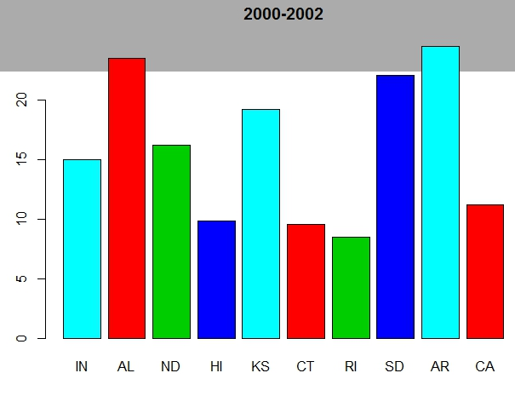
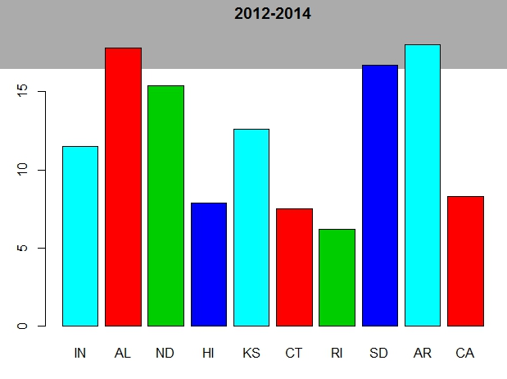

Summary | 2000 - 2002 | 2012 - 2014
Min | 8.50 | 6.20
1st Q | 10.23 | 8.00
Med | 15.60 | 12.05
3rd Q | 21.38 | 16.38
Max | 24.50 | 18.00
Mean | 15.97 | 12.19

Below is the computer output from the data analysis:

Welch Two Sample t-test

data: first and second
t = 1.569, df = 16.687, p-value = 0.1354
alternative hypothesis: true difference in means is not equal to 0
95 percent confidence interval:
-1.310175 8.870175
sample estimates:
mean of x mean of y
15.97 12.19

Decision
Since the p value of 0.1354 is bigger than the standard value 0.05 level of significance we fail to reject the null hypothesis and conclude that there is no significant difference in the rates of motor vehicle deaths from the year range 2000 - 2002 and the year range 2012 - 2014. The 95% confidence interval for the difference in motor vehicle death rates is (-1.31, 8.87).

Discussion
Initially it seemed as if the rate of motor vehicle deaths had decreased from 2000-2002 to 2012-2014. The former had an average rate of 15.97 while the latter had an average rate of 12.19. However after performing hypothesis testing, the difference is these values was shown to not be statistically significant. It is possible that the sample size was not large enough, I only included 10 randoms states in my statistics instead of all 50.

